UNITED STATES
SECURITIES AND EXCHANGE COMMISSION
Washington, D.C. 20549

FORM 8-K

CURRENT REPORT
Pursuant to Section 13 or 15(d)
of The Securities Exchange Act of 1934

Date of Report (Date of earliest event reported): August 9, 2023

TELA Bio, Inc.
(Exact name of registrant as specified in its charter)

Delaware |  | 001-39130 |  | 45-5320061
(State or other jurisdiction of  incorporation) |  | (Commission  File Number) |  | (I.R.S. Employer  Identification No.)

1 Great Valley Parkway, Suite 24  Malvern, Pennsylvania |  | 19355
(Address of principal executive offices) |  | (Zip Code)

Registrant’s telephone number, including area code: (484) 320-2930

Not Applicable
(Former name or former address, if changed since last report.)

Check the appropriate box below if the Form 8-K filing is intended to simultaneously satisfy the filing obligation of the registrant under any of the following provisions:

☐ | Written communications pursuant to Rule 425 under the Securities Act (17 CFR 230.425)
☐ | Soliciting material pursuant to Rule 14a-12 under the Exchange Act (17 CFR 240.14a-12)
☐ | Pre-commencement communications pursuant to Rule 14d-2(b) under the Exchange Act (17 CFR 240.14d-2(b))
☐ | Pre-commencement communications pursuant to Rule 13e-4(c) under the Exchange Act (17 CFR 240.13e-4(c))

Securities registered pursuant to Section 12(b) of the Act:

Title of each class |  | Trading Symbol(s) |  | Name of each exchange on which registered
Common Stock, par value $0.001 per share |  | TELA |  | Nasdaq Global Market

Indicate by check mark whether the registrant is an emerging growth company as defined in Rule 405 of the Securities Act of 1933 (§230.405 of this chapter) or Rule 12b-2 of the Securities Exchange Act of 1934 (§240.12b-2 of this chapter).

Emerging growth company ☒

If an emerging growth company, indicate by check mark if the registrant has elected not to use the extended transition period for complying with any new or revised financial accounting standards provided pursuant to Section 13(a) of the Exchange Act. ☐

 | Item 2.02 | Results of Operations and Financial Condition.

On August 9, 2023, TELA Bio, Inc. (the “Company”) issued a press release announcing its financial results for the second quarter ended June 30, 2023. A copy of this press release is furnished as Exhibit 99.1 hereto.

The information furnished pursuant to this Item 2.02, including Exhibit 99.1, shall not be deemed “filed” for purposes of Section 18 of the Securities Exchange Act of 1934, as amended (the “Exchange Act”), or otherwise subject to the liabilities of that section, and shall not be deemed to be incorporated by reference in any filing under the Securities Act of 1933, as amended (the “Securities Act”), or the Exchange Act, except as expressly set forth by specific reference in such filing.

 | Item 7.01 | Regulation FD Disclosure.

On August 9, 2023, the Company updated information reflected in a corporate slide deck, which representatives of the Company will use in various meetings with investors from time to time. A copy of the presentation is attached hereto as Exhibit 99.2, and incorporated herein by reference.

The information furnished pursuant to Item 7.01, including Exhibit 99.2, shall not be deemed “filed” for purposes of Section 18 of the Exchange Act or otherwise subject to the liabilities of that section, and shall not be deemed to be incorporated by reference in any filing under the Securities Act or the Exchange Act, except as expressly set forth by specific reference in such filing.

 | Item 9.01 | Financial Statements and Exhibits.

(d) Exhibits

The following exhibits are being furnished herewith:

Exhibit No. |  | Document
99.1 |  | Press Release of TELA Bio, Inc., dated August 9, 2023.
99.2 |  | Corporate Slide Deck, dated August 9, 2023.
104 |  | Cover Page Interactive Data File (embedded within the Inline XBRL document).

SIGNATURES

Pursuant to the requirements of the Securities Exchange Act of 1934, the registrant has duly caused this report to be signed on its behalf by the undersigned hereunto duly authorized.

 | TELA BIO, INC.
 | By: | /s/ Antony Koblish
 | Name: | Antony Koblish
 | Title: | President, Chief Executive Officer and Director

Date: August 9, 2023

Exhibit 99.1



TELA Bio Reports Second Quarter 2023 Financial Results

MALVERN, PA, August 9, 2023 -- TELA Bio, Inc. ("TELA Bio"), a commercial-stage medical technology company focused on providing innovative soft-tissue reconstruction solutions that optimize clinical outcomes by prioritizing the preservation and restoration of the patient's own anatomy, today reported financial results for the second quarter ended June 30, 2023.

Recent Highlights

 | • | Revenue of $14.5 million in the second quarter, representing growth of 39% over the second quarter of 2022;
 | • | Revenue of $26.4 million for the first half of 2023, representing growth of 42% over the same period of 2022;
 | • | Demand for OviTex® and OviTex PRS Reinforced Tissue Matrix increased in the second quarter of 2023, resulting in year-over-year revenue growth of approximately 43% and 31%, respectively;
 | • | Results from a consumer survey highlighted strong consumer desire for shared-decision making and surgeon expertise in innovative, more natural hernia repair options;
 | • | Underwritten public offering yielded net proceeds of approximately $46.4 million; and
 | • | Full year 2023 revenue guidance reaffirmed, with a range of $60.0 million to $65.0 million.

"We are pleased to report another quarter of sequential growth for TELA, driven by increased momentum in the sales organization and improving macroeconomic conditions for elective procedure volumes,” said Antony Koblish, co-founder, President and Chief Executive Officer of TELA Bio. “In the first half of 2023, we grew our top line, increased market share, and launched innovative products and product enhancements to address the varying needs of surgeons and patients in an expanding soft tissue market. We look forward to leveraging our strong first-half performance into the third and fourth quarters and beyond.”

Second Quarter 2023 Financial Results

Revenue was $14.5 million in the second quarter of 2023, an increase of 39% compared to the same period in 2022. The increase was due to the expansion of our commercial organization, the addition of new customers, increased penetration within existing customer accounts, and growing international sales.

Gross profit was $10.2 million in the second quarter of 2023, or 70% of revenue, compared to $6.6 million, or 63% of revenue, in the same period in 2022. The increase in gross margin was primarily due to better inventory management practices resulting in a decrease in the reserve for excess and obsolete inventory as a percentage of revenue as compared to the prior year period.

Operating expenses were $20.6 million in the second quarter of 2023, compared to $16.8 million in the same period in 2022. The increase was due to higher compensation and employee-related expenses from additional headcount as we continue to expand our organization, along with increased travel expenses, increased consulting fees and higher study costs.

Loss from operations was $10.4 million in the second quarter of 2023, compared to a loss from operations of $10.2 million in the same period in 2022.

Net loss was $10.8 million in the second quarter of 2023, compared to a net loss of $12.7. million in the same period in 2022.

Cash and cash equivalents on June 30, 2023 totaled $65.3 million following a public offering which raised approximately $46.4 million dollars after commissions and expenses.

2023 Financial Guidance

We continue to expect full year 2023 revenue to range from $60.0 million to $65.0 million, reflecting growth of 45% to 57% over full year 2022.

Conference Call

TELA Bio will host a conference call at 4:30 p.m. Eastern Time on Wednesday, August 9, 2023 to discuss its second quarter 2023 financial results. Investors interested in listening to the conference call should register online. Participants are required to register a day in advance or at minimum 15 minutes before the start of the call. A replay of the webcast can be accessed via the Events & Presentations page of the investor section of TELA Bio's website.

About TELA Bio, Inc.

TELA Bio, Inc. (NASDAQ: TELA) is a commercial-stage medical technology company focused on providing innovative technologies that optimize clinical outcomes by prioritizing the preservation and restoration of the patient's own anatomy. The Company is committed to providing surgeons with advanced, economically effective soft-tissue reconstruction solutions that leverage the patient's natural healing response while minimizing long-term exposure to permanent synthetic materials. For more information, visit www.telabio.com.

Caution Regarding Forward-Looking Statements

This press release contains forward-looking statements within the meaning of The Private Securities Litigation Reform Act of 1995. Words such as "may," "might," "will," "should," "believe," "expect," "anticipate," "estimate," "continue," "predict," "forecast," "project," "plan," "intend" or similar expressions, or statements regarding intent, belief, or current expectations are forward-looking statements and reflect the current beliefs of TELA Bio's management. Such forward-looking statements include statements relating to our expected revenue and revenue growth for the full year 2023. These statements are not guarantees of future performance and are subject to certain risks, uncertainties and other factors that could cause actual results and events to differ materially and adversely from those indicated by such forward-looking statements including, among others: the impact to our business from macroeconomic conditions, including the COVID-19 pandemic and other public health crises, recessionary concerns, banking instability, increasing market interest rates, and inflationary pressures, potentially impacting our ability to market our products, demand for our products due to the deferral of elective procedures, the labor and staffing environment in the healthcare industry, disruption in our supply chain, or pricing pressures concerning our products or the procedures using our products; our ability to achieve or sustain profitability; our ability to gain market acceptance for our products and to accurately forecast and meet customer demand; our ability to compete successfully; that data from earlier studies related to our products and interim data from ongoing studies may not be replicated in later studies or indicative of future data; that data obtained from clinical studies using our product may not be indicative of outcomes in other surgical settings; our ability to enhance our product offerings; development and manufacturing problems; capacity constraints or delays in production of our products; maintenance of coverage and adequate reimbursement for procedures using our products; product defects or failures. These risks and uncertainties are described more fully in the "Risk Factors" section and elsewhere in our filings with the Securities and Exchange Commission and available at www.sec.gov, including in our Annual Report on Form 10-K and Quarterly Reports on Form 10-Q. Any forward-looking statements that we make in this announcement speak only as of the date of this press release, and TELA Bio assumes no obligation to update forward-looking statements whether as a result of new information, future events or otherwise after the date of this press release, except as required under applicable law.

Investor Contact
Greg Chodaczek
332-895-3230
ir@telabio.com

TELA Bio, Inc.
Consolidated Balance Sheets
(In thousands, except share and per share amounts)
(Unaudited)

 |  | June 30, |  |  |  | December 31,
 |  | 2023 |  |  |  | 2022
Assets
Current assets:
Cash and cash equivalents |  | $ | 65,266 |  |  | $ | 42,019
Accounts receivable, net |  |  | 7,894 |  |  |  | 6,621
Inventory |  |  | 14,098 |  |  |  | 11,792
Prepaid expenses and other assets |  |  | 1,910 |  |  |  | 2,015
Total current assets |  |  | 89,168 |  |  |  | 62,447
Property and equipment, net |  |  | 1,764 |  |  |  | 1,682
Intangible assets, net |  |  | 2,309 |  |  |  | 2,499
Right-of-use assets |  |  | 1,145 |  |  |  | 1,227
Total assets |  | $ | 94,386 |  |  | $ | 67,855
Liabilities and stockholders’ equity
Current liabilities:
Accounts payable |  | $ | 2,250 |  |  | $ | 1,534
Accrued expenses and other current liabilities |  |  | 10,795 |  |  |  | 10,869
Total current liabilities |  |  | 13,045 |  |  |  | 12,403
Long-term debt |  |  | 40,212 |  |  |  | 39,916
Other long-term liabilities |  |  | 1,124 |  |  |  | 1,231
Total liabilities |  |  | 54,381 |  |  |  | 53,550
Stockholders’ equity:
Preferred stock; $0.001 par value: 10,000,000 shares authorized; no shares issued and outstanding |  |  | — |  |  |  | —
Common stock; $0.001 par value: 200,000,000 shares authorized; 24,475,504 and 19,165,027 shares issued and outstanding at June 30, 2023 and December 31, 2022, respectively |  |  | 24 |  |  |  | 19
Additional paid-in capital |  |  | 336,939 |  |  |  | 288,361
Accumulated other comprehensive income |  |  | 84 |  |  |  | 150
Accumulated deficit |  |  | (297,042 | ) |  |  | (274,225 | )
Total stockholders’ equity |  |  | 40,005 |  |  |  | 14,305
Total liabilities and stockholders’ equity |  | $ | 94,386 |  |  | $ | 67,855

TELA Bio, Inc.
Consolidated Statements of Operations and Comprehensive Loss
(In thousands, except share and per share amounts)
(Unaudited)

 |  | Three months ended June 30, |  |  |  |  |  |  |  | Six months ended June 30,
 |  | 2023 |  |  |  | 2022 |  |  |  | 2023 |  |  |  | 2022
Revenue |  | $ | 14,494 |  |  | $ | 10,406 |  |  | $ | 26,403 |  |  | $ | 18,637
Cost of revenue (excluding amortization of intangible assets) |  |  | 4,198 |  |  |  | 3,318 |  |  |  | 8,114 |  |  |  | 6,474
Amortization of intangible assets |  |  | 95 |  |  |  | 538 |  |  |  | 190 |  |  |  | 614
Gross profit |  |  | 10,201 |  |  |  | 6,550 |  |  |  | 18,099 |  |  |  | 11,549
Operating expenses:
Sales and marketing |  |  | 14,577 |  |  |  | 11,055 |  |  |  | 28,043 |  |  |  | 20,433
General and administrative |  |  | 3,472 |  |  |  | 3,630 |  |  |  | 7,106 |  |  |  | 7,088
Research and development |  |  | 2,514 |  |  |  | 2,102 |  |  |  | 4,566 |  |  |  | 4,109
Total operating expenses |  |  | 20,563 |  |  |  | 16,787 |  |  |  | 39,715 |  |  |  | 31,630
Loss from operations |  |  | (10,362 | ) |  |  | (10,237 | ) |  |  | (21,616 | ) |  |  | (20,081 | )
Other expense:
Interest expense |  |  | (1,298 | ) |  |  | (934 | ) |  |  | (2,544 | ) |  |  | (1,845 | )
Loss on extinguishment of debt |  |  | — |  |  |  | (1,228 | ) |  |  | — |  |  |  | (1,228 | )
Other income (expense) |  |  | 870 |  |  |  | (342 | ) |  |  | 1,343 |  |  |  | (449 | )
Total other expense |  |  | (428 | ) |  |  | (2,504 | ) |  |  | (1,201 | ) |  |  | (3,522 | )
Net loss |  | $ | (10,790 | ) |  | $ | (12,741 | ) |  | $ | (22,817 | ) |  | $ | (23,603 | )
Net loss per common share, basic and diluted |  | $ | (0.46 | ) |  | $ | (0.88 | ) |  | $ | (1.08 | ) |  | $ | (1.62 | )
Weighted average common shares outstanding, basic and diluted |  |  | 23,239,262 |  |  |  | 14,557,453 |  |  |  | 21,223,639 |  |  |  | 14,548,210
Comprehensive loss:
Net loss |  | $ | (10,790 | ) |  | $ | (12,741 | ) |  | $ | (22,817 | ) |  | $ | (23,603 | )
Foreign currency translation adjustment |  |  | (36 | ) |  |  | 134 |  |  |  | (66 | ) |  |  | 181
Comprehensive loss |  | $ | (10,826 | ) |  | $ | (12,607 | ) |  | $ | (22,883 | ) |  | $ | (23,422 | )

Exhibit 99.2
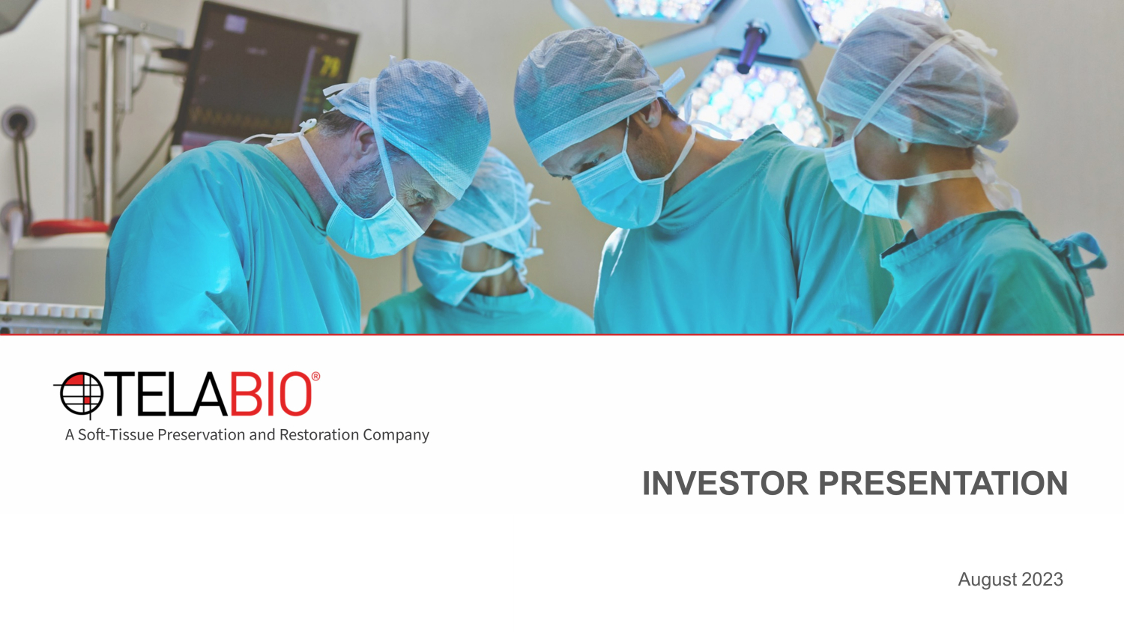
INVESTOR PRESENTATION August 2023

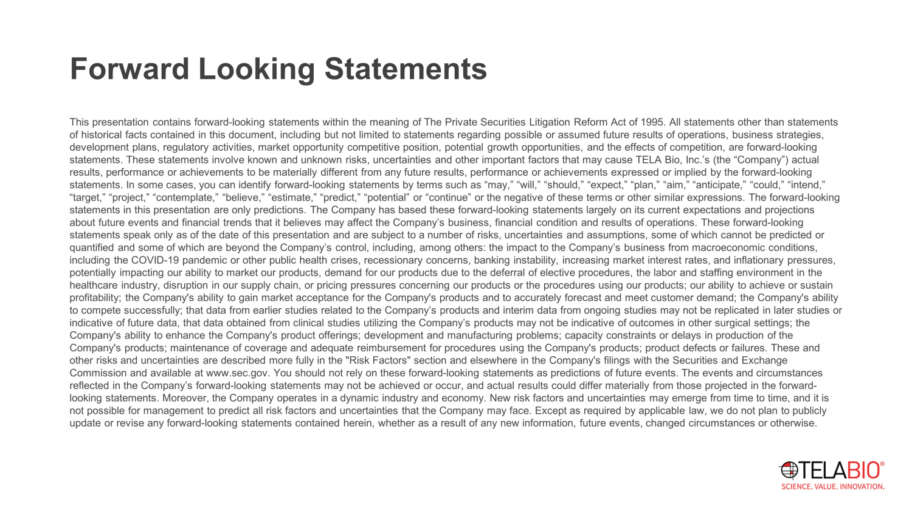
Forward Looking Statements This presentation contains forward - looking statements within the meaning of The Private Securities Litigation Reform Act of 1995 . All statements other than statements of historical facts contained in this document, including but not limited to statements regarding possible or assumed future res ults of operations, business strategies, development plans, regulatory activities, market opportunity competitive position, potential growth opportunities, and the ef fec ts of competition, are forward - looking statements. These statements involve known and unknown risks, uncertainties and other important factors that may cause TELA B io, Inc.’s (the “Company”) actual results, performance or achievements to be materially different from any future results, performance or achievements expresse d o r implied by the forward - looking statements. In some cases, you can identify forward - looking statements by terms such as “may,” “will,” “should,” “expect,” “plan ,” “aim,” “anticipate,” “could,” “intend,” “target,” “project,” “contemplate,” “believe,” “estimate,” “predict,” “potential” or “continue” or the negative of these term s o r other similar expressions. The forward - looking statements in this presentation are only predictions. The Company has based these forward - looking statements largely on its curr ent expectations and projections about future events and financial trends that it believes may affect the Company’s business, financial condition and results of operations. These forward - looking statements speak only as of the date of this presentation and are subject to a number of risks, uncertainties and assumptions , s ome of which cannot be predicted or quantified and some of which are beyond the Company’s control, including, among others: the impact to the Company’s business fro m macroeconomic conditions, including the COVID - 19 pandemic or other public health crises, recessionary concerns, banking instability, increasing market interest rates, and inflationary pressures, potentially impacting our ability to market our products, demand for our products due to the deferral of elective procedures, th e labor and staffing environment in the healthcare industry, disruption in our supply chain, or pricing pressures concerning our products or the procedures using our pr oducts; our ability to achieve or sustain profitability; the Company's ability to gain market acceptance for the Company's products and to accurately forecast and meet cu stomer demand; the Company's ability to compete successfully; that data from earlier studies related to the Company’s products and interim data from ongoing studi es may not be replicated in later studies or indicative of future data, that data obtained from clinical studies utilizing the Company’s products may not be indicative of ou tcomes in other surgical settings; the Company's ability to enhance the Company's product offerings; development and manufacturing problems; capacity constraints or de lays in production of the Company's products; maintenance of coverage and adequate reimbursement for procedures using the Company's products; product d efe cts or failures. These and other risks and uncertainties are described more fully in the "Risk Factors" section and elsewhere in the Company's filings w ith the Securities and Exchange Commission and available at www.sec.gov. You should not rely on these forward - looking statements as predictions of future events . The events and circumstances reflected in the Company’s forward - looking statements may not be achieved or occur, and actual results could differ materially f rom those projected in the forward - looking statements. Moreover, the Company operates in a dynamic industry and economy. New risk factors and uncertainties may eme rge from time to time, and it is not possible for management to predict all risk factors and uncertainties that the Company may face. Except as required by ap pli cable law, we do not plan to publicly update or revise any forward - looking statements contained herein, whether as a result of any new information, future events, cha nged circumstances or otherwise.

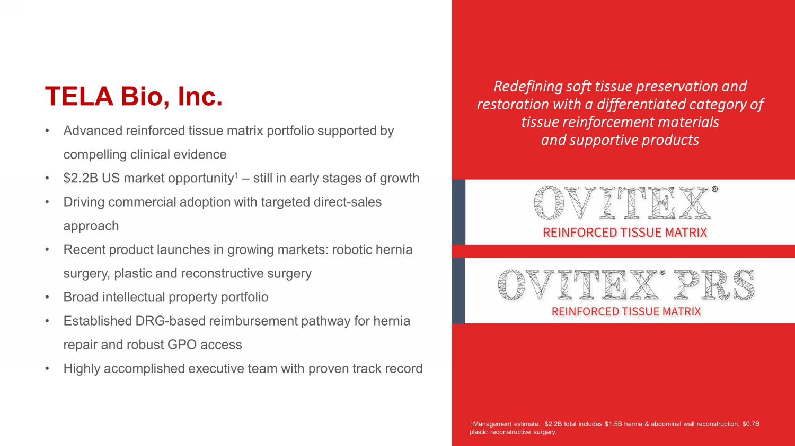
TELA Bio, Inc. • Advanced reinforced tissue matrix portfolio supported by compelling clinical evidence • $2.2B US market opportunity 1 – still in early stages of growth • Driving commercial adoption with targeted direct - sales approach • Recent product launches in growing markets: robotic hernia surgery, plastic and reconstructive surgery • Broad intellectual property portfolio • Established DRG - based reimbursement pathway for hernia repair and robust GPO access • Highly accomplished executive team with proven track record 1 Management estimate. $2.2B total includes $1.5B hernia & abdominal wall reconstruction, $0.7B plastic reconstructive surgery. Redefining soft tissue preservation and restoration with a differentiated category of tissue reinforcement materials and supportive products

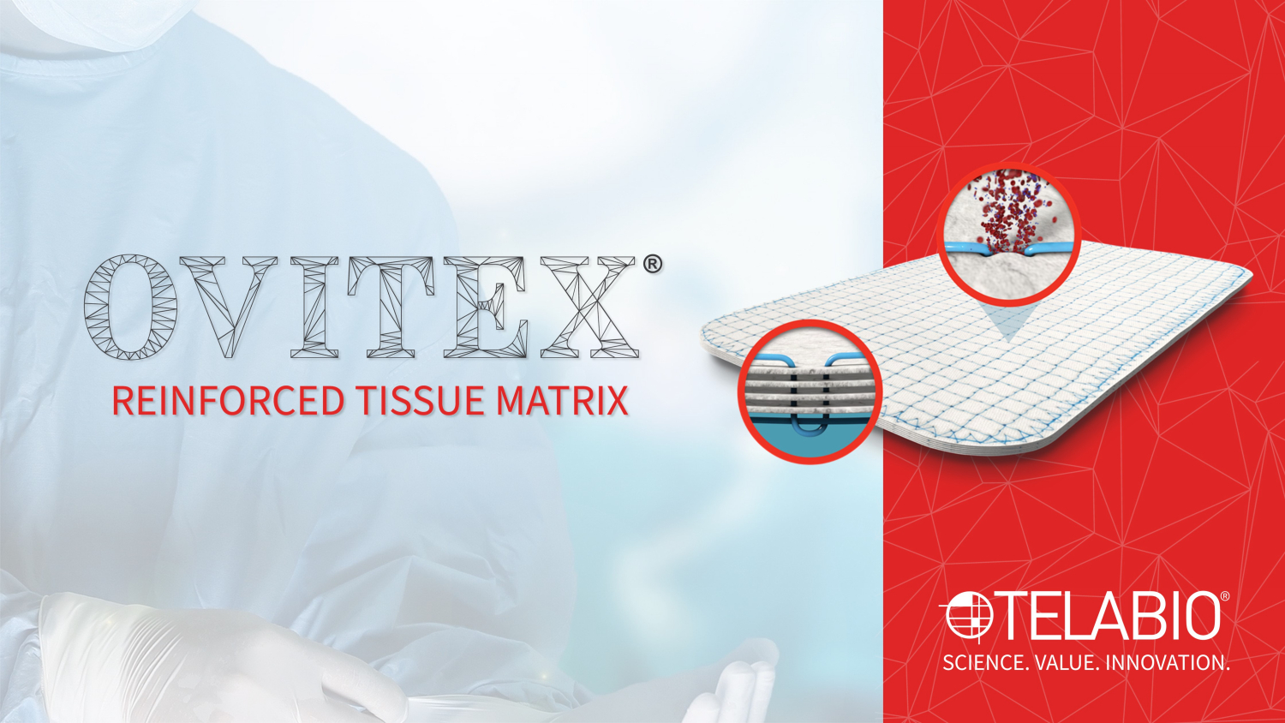

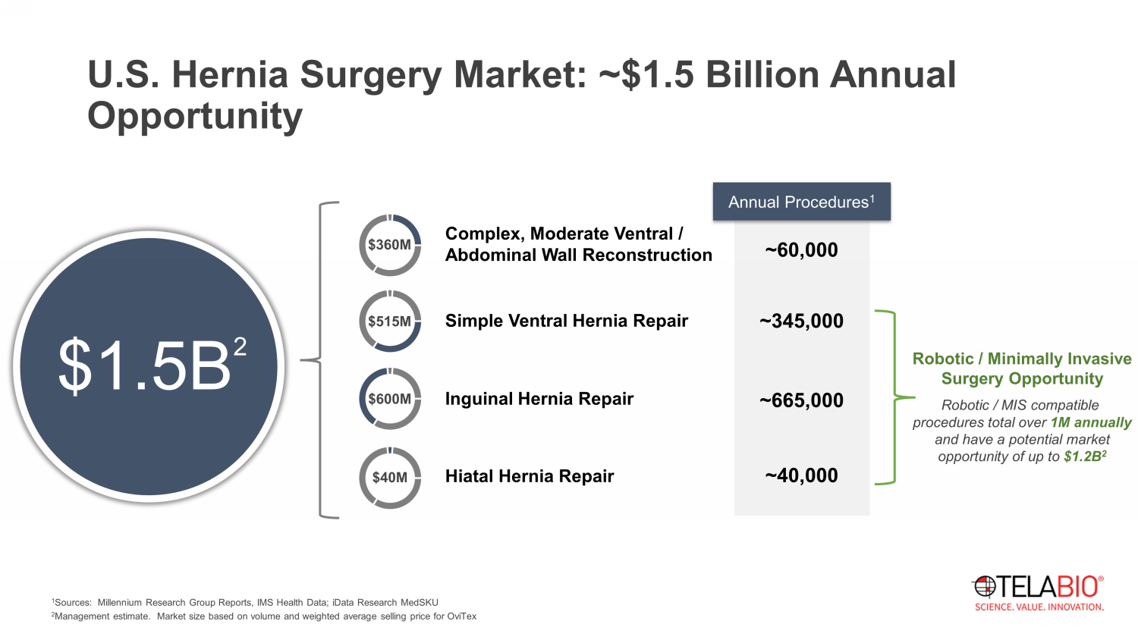
Complex, Moderate Ventral / Abdominal Wall Reconstruction Simple Ventral Hernia Repair Inguinal Hernia Repair Hiatal Hernia Repair ~60,000 ~345,000 ~665,000 ~40,000 $360M $515M $600M $40M 1 Sources: Millennium Research Group Reports, IMS Health Data; iData Research MedSKU 2 Management estimate. Market size based on volume and weighted average selling price for OviTex Annual Procedures 1 $1.5B 2 Robotic / Minimally Invasive Surgery Opportunity U.S. Hernia Surgery Market: ~$1.5 Billion Annual Opportunity Robotic / MIS compatible procedures total over 1M annually and have a potential market opportunity of up to $1.2B 2

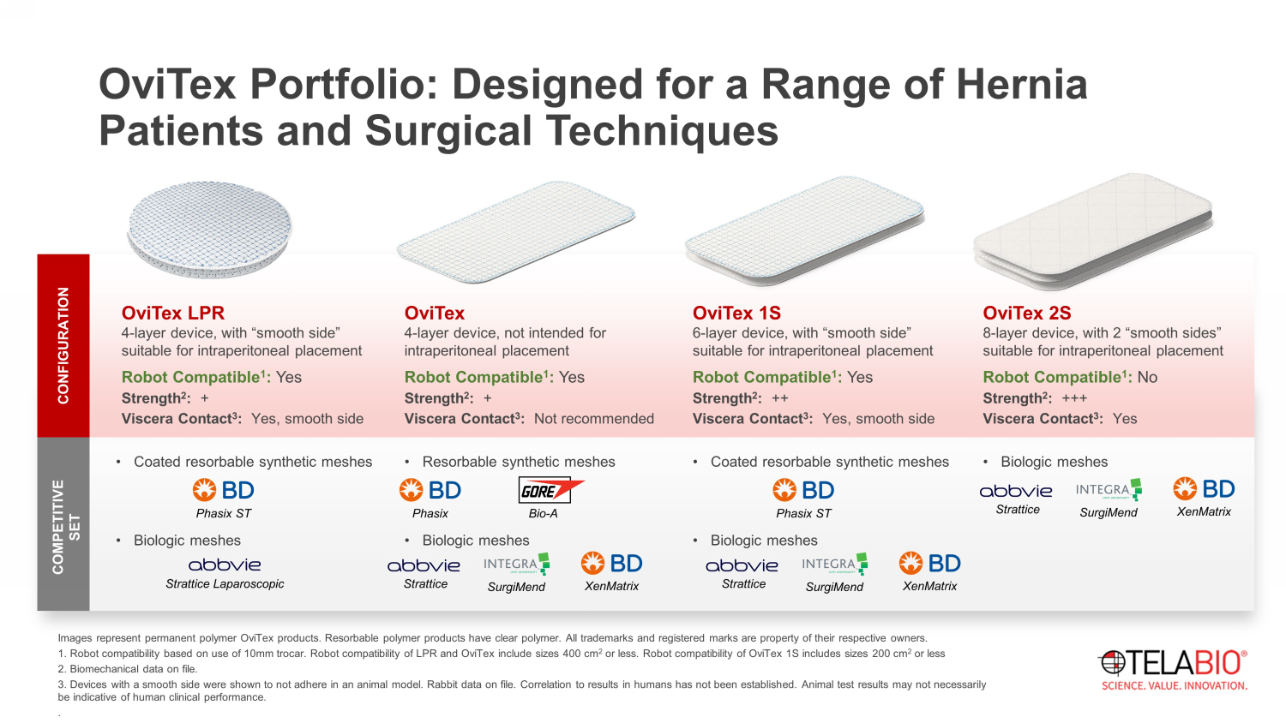
OviTex Portfolio: Designed for a Range of Hernia Patients and Surgical Techniques • Coated resorbable synthetic meshes • Biologic meshes • Biologic meshes CONFIGURATION OviTex 2S 8 - layer device, with 2 “smooth sides” suitable for intraperitoneal placement Robot Compatible 1 : No Strength 2 : +++ Viscera Contact 3 : Yes OviTex 1S 6 - layer device, with “smooth side” suitable for intraperitoneal placement Robot Compatible 1 : Yes Strength 2 : ++ Viscera Contact 3 : Yes, smooth side COMPETITIVE SET • Coated resorbable synthetic meshes • Biologic meshes OviTex LPR 4 - layer device, with “smooth side” suitable for intraperitoneal placement Robot Compatible 1 : Yes Strength 2 : + Viscera Contact 3 : Yes, smooth side • Resorbable synthetic meshes • Biologic meshes OviTex 4 - layer device, not intended for intraperitoneal placement Robot Compatible 1 : Yes Strength 2 : + Viscera Contact 3 : Not recommended Images represent permanent polymer OviTex products. Resorbable polymer products have clear polymer. All trademarks and regist ere d marks are property of their respective owners. 1. Robot compatibility based on use of 10mm trocar. Robot compatibility of LPR and OviTex include sizes 400 cm 2 or less. Robot compatibility of OviTex 1S includes sizes 200 cm 2 or less 2. Biomechanical data on file. 3. Devices with a smooth side were shown to not adhere in an animal model. Rabbit data on file. Correlation to results in hum ans has not been established. Animal test results may not necessarily be indicative of human clinical performance. . Strattice Laparoscopic Phasix ST Bio - A SurgiMend Phasix Strattice XenMatrix SurgiMend Strattice XenMatrix SurgiMend Strattice XenMatrix Phasix ST

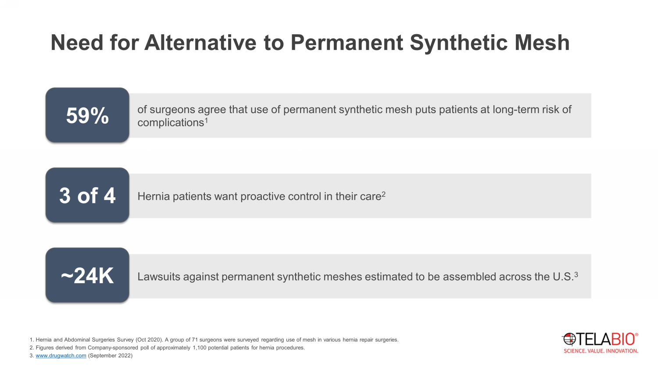
Lawsuits against permanent synthetic meshes estimated to be assembled across the U.S. 3 of surgeons agree that use of permanent synthetic mesh puts patients at long - term risk of complications 1 1. Hernia and Abdominal Surgeries Survey (Oct 2020). A group of 71 surgeons were surveyed regarding use of mesh in various hernia repai r surgeries. 2. Figures derived from Company - sponsored poll of approximately 1,100 potential patients for hernia procedures. 3. www.drugwatch.com (September 2022) 59% Hernia patients want proactive control in their care 2 3 of 4 ~ 24 K Need for Alternative to Permanent Synthetic Mesh

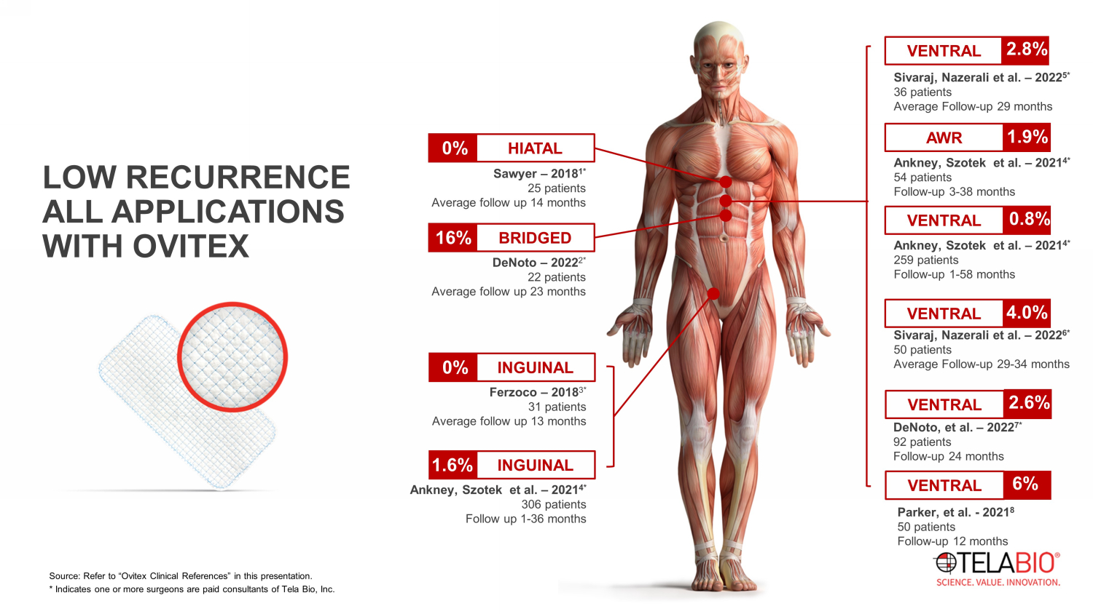
LOW RECURRENCE ALL APPLICATIONS WITH OVITEX Ankney , Szotek et al. – 2021 4 * 54 patients Follow - up 3 - 38 months Ferzoco – 2018 3 * 31 patients Average follow up 13 months INGUINAL 0% Ankney , Szotek et al. – 2021 4 * 306 patients Follow up 1 - 36 months INGUINAL 1.6% Sawyer – 2018 1 * 25 patients Average follow up 14 months HIATAL 0% DeNoto – 2022 2 * 22 patients Average follow up 23 months BRIDGED 16% AWR 1.9% Parker, et al. - 2021 8 50 patients Follow - up 12 months VENTRAL 6% DeNoto, et al. – 2022 7 * 92 patients Follow - up 24 months VENTRAL 2.6% Ankney , Szotek et al. – 2021 4 * 259 patients Follow - up 1 - 58 months VENTRAL 0.8% Sivaraj , Nazerali et al. – 2022 5 * 36 patients Average Follow - up 29 months VENTRAL 2.8% Source: Refer to “ Ovitex Clinical References” in this presentation. * Indicates one or more surgeons are paid consultants of Tela Bio, Inc. Sivaraj , Nazerali et al. – 2022 6 * 50 patients Average Follow - up 29 - 34 months VENTRAL 4.0%

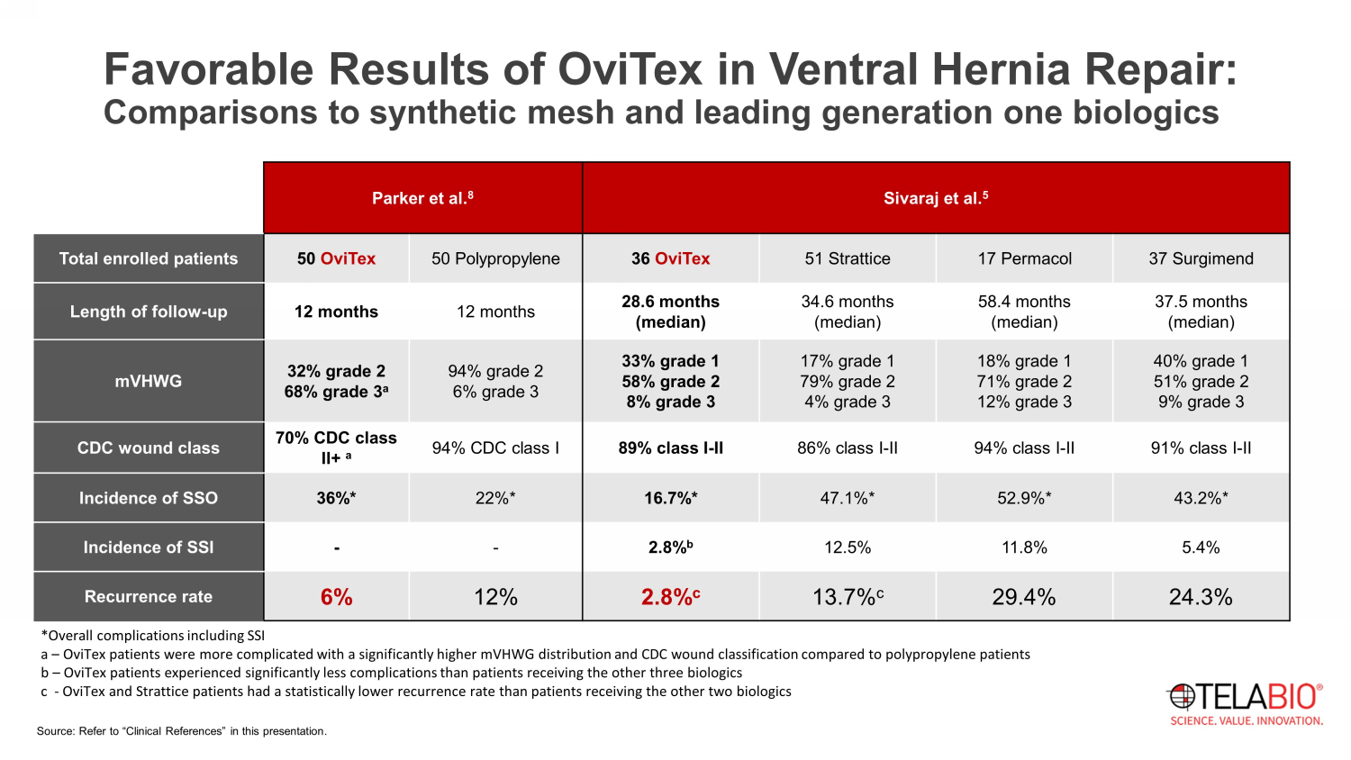
Parker et al. 8 Sivaraj et al. 5 Total enrolled patients 50 OviTex 50 Polypropylene 36 OviTex 51 Strattice 17 Permacol 37 Surgimend Length of follow - up 12 months 12 months 28.6 months (median) 34.6 months (median) 58.4 months (median) 37.5 months (median) mVHWG 32% grade 2 68% grade 3 a 94% grade 2 6% grade 3 33% grade 1 58% grade 2 8% grade 3 17% grade 1 79% grade 2 4% grade 3 18% grade 1 71% grade 2 12% grade 3 40% grade 1 51% grade 2 9% grade 3 CDC wound class 70% CDC class II+ a 94% CDC class I 89% class I - II 86% class I - II 94% class I - II 91% class I - II Incidence of SSO 36%* 22%* 16.7%* 47.1%* 52.9%* 43.2%* Incidence of SSI - - 2.8% b 12.5% 11.8% 5.4% Recurrence rate 6% 12% 2.8% c 13.7% c 29.4% 24.3% Source: Refer to “Clinical References” in this presentation. Favorable Results of OviTex in Ventral Hernia Repair: Comparisons to synthetic mesh and leading generation one biologics *Overall complications including SSI a – OviTex patients were more complicated with a significantly higher mVHWG distribution and CDC wound classification compared to polypropylene patients b – OviTex patients experienced significantly less complications than patients receiving the other three biologics c - OviTex and Strattice patients had a statistically lower recurrence rate than patients receiving the other two biologics

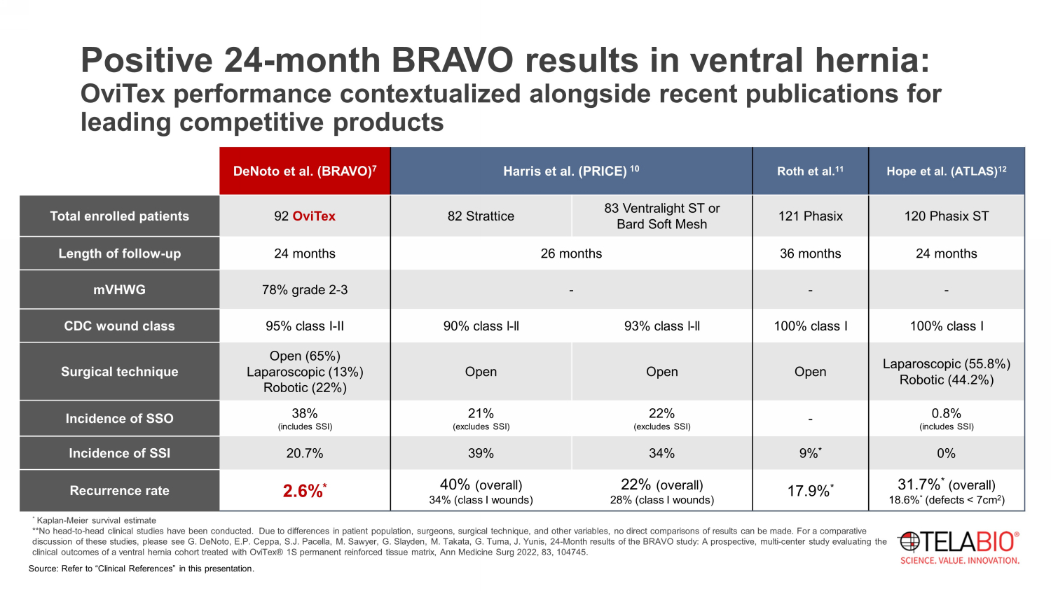
* Kaplan - Meier survival estimate **No head - to - head clinical studies have been conducted. Due to differences in patient population, surgeons, surgical technique, and other variables, no direct comparisons of results can be made. For a comparative discussion of these studies, please see G. DeNoto , E.P. Ceppa , S.J. Pacella, M. Sawyer, G. Slayden , M. Takata, G. Tuma , J. Yunis, 24 - Month results of the BRAVO study: A prospective, multi - center study evaluating the clinical outcomes of a ventral hernia cohort treated with OviTex ® 1S permanent reinforced tissue matrix, Ann Medicine Surg 2022, 83, 104745 . Positive 24 - month BRAVO results in ventral hernia: OviTex performance contextualized alongside recent publications for leading competitive products DeNoto et al. (BRAVO) 7 Harris et al. (PRICE) 10 Roth et al. 11 Hope et al. (ATLAS) 12 Total enrolled patients 92 OviTex 82 Strattice 83 Ventralight ST or Bard Soft Mesh 121 Phasix 120 Phasix ST Length of follow - up 24 months 26 months 36 months 24 months mVHWG 78% grade 2 - 3 - - - CDC wound class 95% class I - II 90% class l - ll 93% class l - ll 100% class I 100% class I Surgical technique Open (65%) Laparoscopic (13%) Robotic (22%) Open Open Open Laparoscopic (55.8%) Robotic (44.2%) Incidence of SSO 38% (includes SSI) 21% (excludes SSI) 22% (excludes SSI) - 0.8% (includes SSI) Incidence of SSI 20.7% 39% 34% 9% * 0% Recurrence rate 2.6% * 40% (overall) 34% (class I wounds) 22% (overall) 28% (class I wounds) 17.9% * 31.7% * (overall) 18.6% * (defects < 7cm 2 ) Source: Refer to “Clinical References” in this presentation.

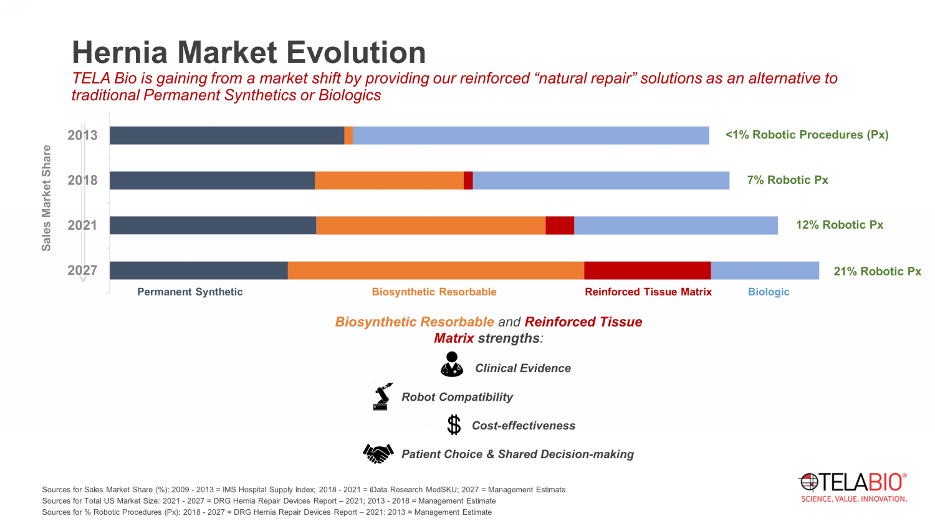
Permanent Synthetic Biologic Biosynthetic Resorbable Reinforced Tissue Matrix Sources for Sales Market Share (%): 2009 - 2013 = IMS Hospital Supply Index; 2018 - 2021 = iData Research MedSKU ; 2027 = Management Estimate Sources for Total US Market Size: 2021 - 2027 = DRG Hernia Repair Devices Report – 2021; 2013 - 2018 = Management Estimate Sources for % Robotic Procedures ( Px ): 2018 - 2027 = DRG Hernia Repair Devices Report – 2021: 2013 = Management Estimate 2027 2021 2018 2013 Sales Market Share Biosynthetic Resorbable and Reinforced Tissue Matrix strengths : Clinical Evidence Robot Compatibility Cost - effectiveness Patient Choice & Shared Decision - making <1% Robotic Procedures ( Px ) 7% Robotic Px 12% Robotic Px 21% Robotic Px Hernia Market Evolution TELA Bio is gaining from a market shift by providing our reinforced “natural repair” solutions as an alternative to traditional Permanent Synthetics or Biologics

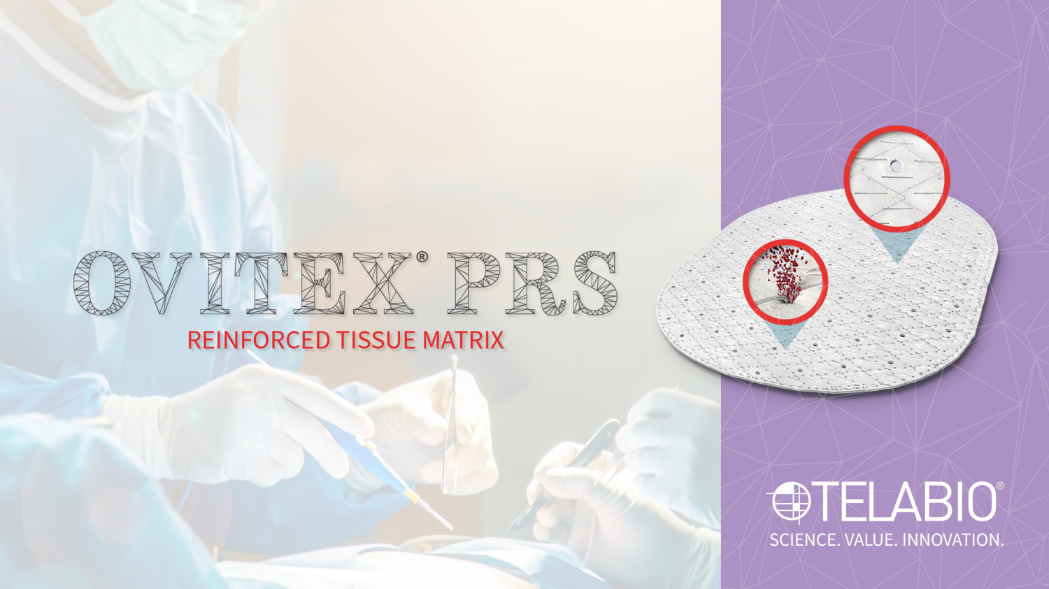

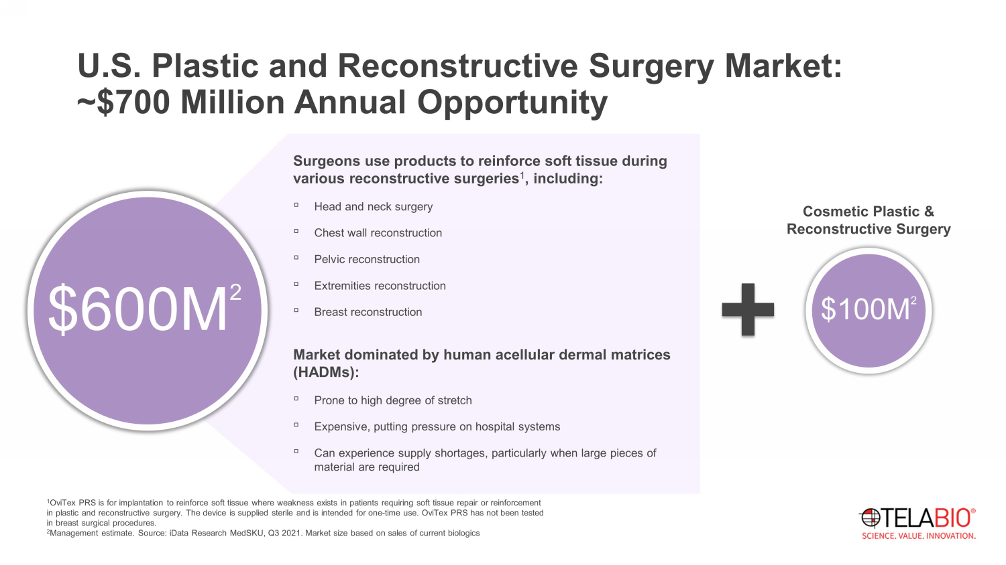
U.S. Plastic and Reconstructive Surgery Market: ~$700 Million Annual Opportunity Surgeons use products to reinforce soft tissue during various reconstructive surgeries 1 , including: ▫ Head and neck surgery ▫ Chest wall reconstruction ▫ Pelvic reconstruction ▫ Extremities reconstruction ▫ Breast reconstruction 1 OviTex PRS is for implantation to reinforce soft tissue where weakness exists in patients requiring soft tissue repair or rei nfo rcement in plastic and reconstructive surgery. The device is supplied sterile and is intended for one - time use. OviTex PRS has not been tested in breast surgical procedures. 2 Management estimate. Source: iData Research MedSKU , Q3 2021. Market size based on sales of current biologics Cosmetic Plastic & Reconstructive Surgery $600M 2 $100M 2 Market dominated by human acellular dermal matrices (HADMs): ▫ Prone to high degree of stretch ▫ Expensive, putting pressure on hospital systems ▫ Can experience supply shortages, particularly when large pieces of material are required

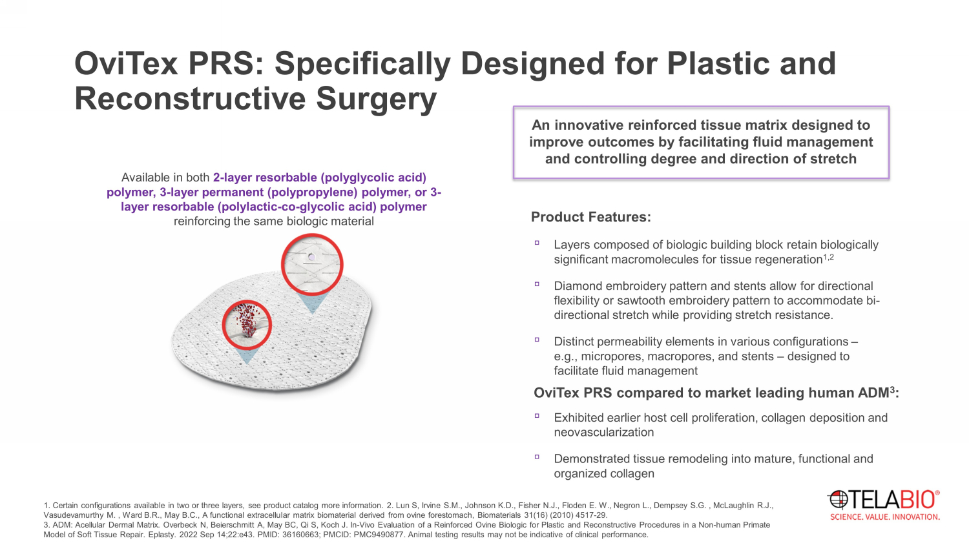
OviTex PRS: Specifically Designed for Plastic and Reconstructive Surgery An innovative reinforced tissue matrix designed to improve outcomes by facilitating fluid management and controlling degree and direction of stretch Product Features: ▫ Layers composed of biologic building block retain biologically significant macromolecules for tissue regeneration 1,2 ▫ Diamond embroidery pattern and stents allow for directional flexibility or sawtooth embroidery pattern to accommodate bi - directional stretch while providing stretch resistance. ▫ Distinct permeability elements in various configurations – e.g., micropores, macropores, and stents – designed to facilitate fluid management Available in both 2 - layer resorbable (polyglycolic acid) polymer, 3 - layer permanent (polypropylene) polymer, or 3 - layer resorbable (polylactic - co - glycolic acid) polymer reinforcing the same biologic material 1 . Certain configurations available in two or three layers, see product catalog more information. 2. Lun S, Irvine S.M., Johnson K.D., Fisher N.J., Floden E. W., Negron L., Dempsey S.G. , McLaughlin R.J., Vasudevamurthy M. , Ward B.R., May B.C., A functional extracellular matrix biomaterial derived from ovine forestomach, Biomaterials 31(16) ( 20 10) 4517 - 29. 3. ADM: Acellular Dermal Matrix. Overbeck N, Beierschmitt A, May BC, Qi S, Koch J. In - Vivo Evaluation of a Reinforced Ovine Biologic for Plastic and Reconstructi ve Procedures in a Non - human Primate Model of Soft Tissue Repair. Eplasty . 2022 Sep 14;22:e43. PMID: 36160663; PMCID: PMC9490877. Animal testing results may not be indicative of clinical performance. OviTex PRS compared to market leading human ADM 3 : ▫ Exhibited earlier host cell proliferation, collagen deposition and neovascularization ▫ Demonstrated tissue remodeling into mature, functional and organized collagen

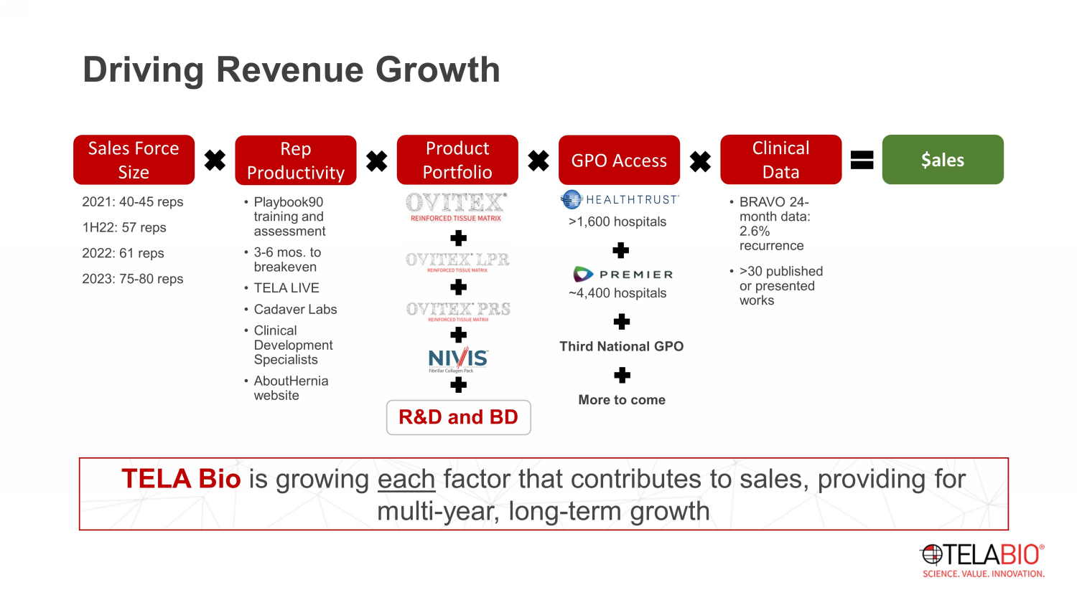
TELA Bio is growing each factor that contributes to sales, providing for multi - year, long - term growth 2021: 40 - 45 reps 1H22: 57 reps 2022: 61 reps 2023: 75 - 80 reps Driving Revenue Growth Rep Productivity Sales Force Size Product Portfolio GPO Access Clinical Data $ales • Playbook90 training and assessment • 3 - 6 mos. to breakeven • TELA LIVE • Cadaver Labs • Clinical Development Specialists • AboutHernia website • BRAVO 24 - month data: 2.6% recurrence • >30 published or presented works >1,600 hospitals ~4,400 hospitals R&D and BD Third National GPO More to come

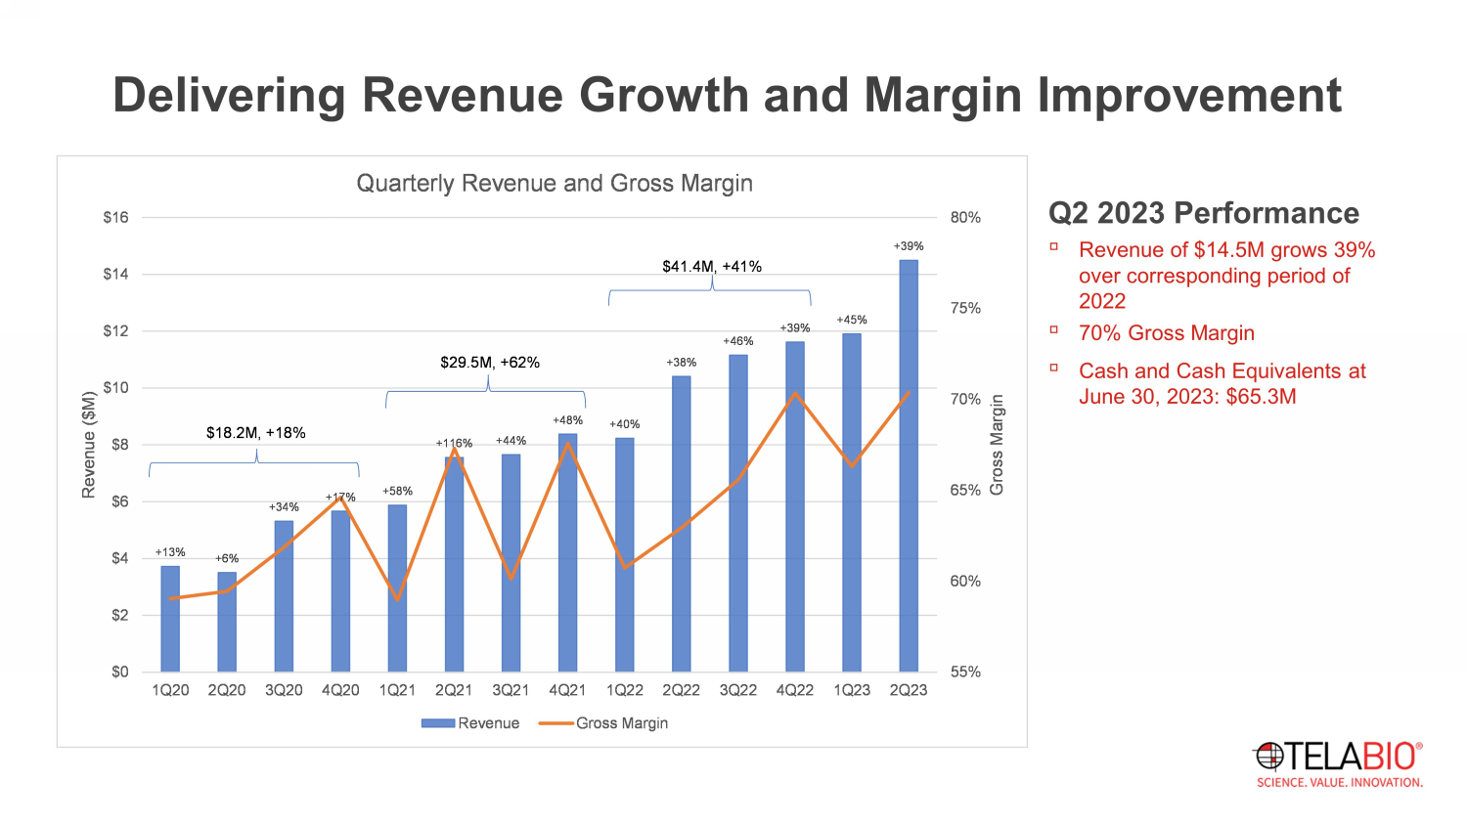
Delivering Revenue Growth and Margin Improvement Q2 2023 Performance ▫ Revenue of $14.5M grows 39% over corresponding period of 2022 ▫ 70% Gross Margin ▫ Cash and Cash Equivalents at June 30, 2023: $65.3M +13% +6% +34% +17% +58% +116% +44% +48% +40% +38% +46% +39% +45% +39% 55% 60% 65% 70% 75% 80% $0 $2 $4 $6 $8 $10 $12 $14 $16 1Q20 2Q20 3Q20 4Q20 1Q21 2Q21 3Q21 4Q21 1Q22 2Q22 3Q22 4Q22 1Q23 2Q23 Gross Margin Revenue ($M) Quarterly Revenue and Gross Margin Revenue Gross Margin $18.2M, +18% $29.5M, +62% $41.4M, +41%

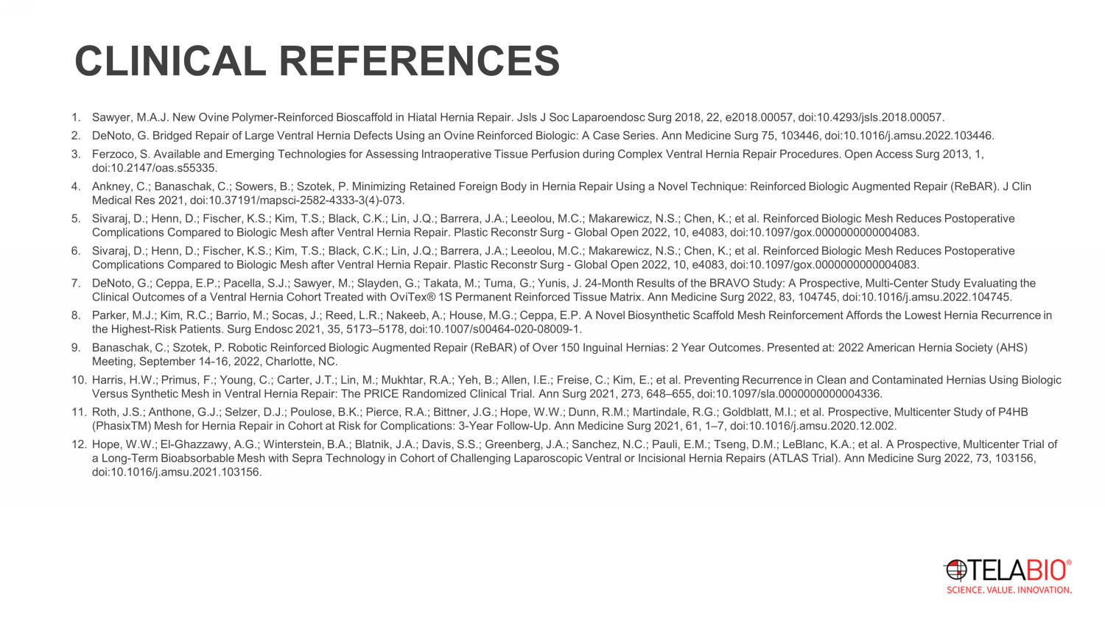
CLINICAL REFERENCES 1. Sawyer, M.A.J. New Ovine Polymer - Reinforced Bioscaffold in Hiatal Hernia Repair. Jsls J Soc Laparoendosc Surg 2018, 22, e2018.00057, doi:10.4293/jsls.2018.00057. 2. DeNoto, G. Bridged Repair of Large Ventral Hernia Defects Using an Ovine Reinforced Biologic: A Case Series. Ann Medicine Sur g 7 5, 103446, doi:10.1016/j.amsu.2022.103446. 3. Ferzoco, S. Available and Emerging Technologies for Assessing Intraoperative Tissue Perfusion during Complex Ventral Hernia R epa ir Procedures. Open Access Surg 2013, 1, doi:10.2147/oas.s55335. 4. Ankney , C.; Banaschak , C.; Sowers, B.; Szotek , P. Minimizing Retained Foreign Body in Hernia Repair Using a Novel Technique: Reinforced Biologic Augmented Repair ( ReBAR ). J Clin Medical Res 2021, doi:10.37191/mapsci - 2582 - 4333 - 3(4) - 073. 5. Sivaraj , D.; Henn, D.; Fischer, K.S.; Kim, T.S.; Black, C.K.; Lin, J.Q.; Barrera, J.A.; Leeolou , M.C.; Makarewicz , N.S.; Chen, K.; et al. Reinforced Biologic Mesh Reduces Postoperative Complications Compared to Biologic Mesh after Ventral Hernia Repair. Plastic Reconstr Surg - Global Open 2022, 10, e4083, doi:10.1097/gox.0000000000004083. 6. Sivaraj , D.; Henn, D.; Fischer, K.S.; Kim, T.S.; Black, C.K.; Lin, J.Q.; Barrera, J.A.; Leeolou , M.C.; Makarewicz , N.S.; Chen, K.; et al. Reinforced Biologic Mesh Reduces Postoperative Complications Compared to Biologic Mesh after Ventral Hernia Repair. Plastic Reconstr Surg - Global Open 2022, 10, e4083, doi:10.1097/gox.0000000000004083. 7. DeNoto, G.; Ceppa, E.P.; Pacella, S.J.; Sawyer, M.; Slayden, G.; Takata, M.; Tuma, G.; Yunis, J. 24 - Month Results of the BRAVO S tudy: A Prospective, Multi - Center Study Evaluating the Clinical Outcomes of a Ventral Hernia Cohort Treated with OviTex ® 1S Permanent Reinforced Tissue Matrix. Ann Medicine Surg 2022, 83, 104745, doi:10.1016/j.amsu.2022.104745. 8. Parker, M.J.; Kim, R.C.; Barrio, M.; Socas , J.; Reed, L.R.; Nakeeb , A.; House, M.G.; Ceppa, E.P. A Novel Biosynthetic Scaffold Mesh Reinforcement Affords the Lowest Hernia Recurrence in the Highest - Risk Patients. Surg Endosc 2021, 35, 5173 – 5178, doi:10.1007/s00464 - 020 - 08009 - 1. 9. Banaschak , C.; Szotek, P. Robotic Reinforced Biologic Augmented Repair ( ReBAR ) of Over 150 Inguinal Hernias: 2 Year Outcomes. Presented at: 2022 American Hernia Society (AHS) Meeting, September 14 - 16, 2022, Charlotte, NC. 10. Harris, H.W.; Primus, F.; Young, C.; Carter, J.T.; Lin, M.; Mukhtar, R.A.; Yeh, B.; Allen, I.E.; Freise , C.; Kim, E.; et al. Preventing Recurrence in Clean and Contaminated Hernias Using Biologic Versus Synthetic Mesh in Ventral Hernia Repair: The PRICE Randomized Clinical Trial. Ann Surg 2021, 273, 648 – 655, doi:10.1097/sl a.0000000000004336. 11. Roth, J.S.; Anthone , G.J.; Selzer, D.J.; Poulose , B.K.; Pierce, R.A.; Bittner, J.G.; Hope, W.W.; Dunn, R.M.; Martindale, R.G.; Goldblatt, M.I.; et al. Prospective, Multicent er Study of P4HB (PhasixTM) Mesh for Hernia Repair in Cohort at Risk for Complications: 3 - Year Follow - Up. Ann Medicine Surg 2021, 61, 1 – 7, doi:10 .1016/j.amsu.2020.12.002. 12. Hope, W.W.; El - Ghazzawy , A.G.; Winterstein , B.A.; Blatnik , J.A.; Davis, S.S.; Greenberg, J.A.; Sanchez, N.C.; Pauli, E.M.; Tseng, D.M.; LeBlanc, K.A.; et al. A Prospective, Multicent er Trial of a Long - Term Bioabsorbable Mesh with Sepra Technology in Cohort of Challenging Laparoscopic Ventral or Incisional Hernia Repairs (ATLAS Trial). Ann Medicine Surg 2022, 73 , 103156, doi:10.1016/j.amsu.2021.103156.

